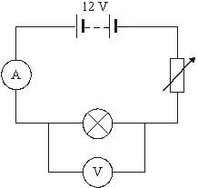
Q1

Jack performed an experiment to find out the relationship between the current that flowed through a lamp and the p.d. (voltage) across it.
He changed the potential difference across it (the voltage) in equal steps from 0V to 10V

(a) What was the dependent variable in his investigation?

(b) What was the independent variable in his investigation?

(c) What type of variable was the voltage – continuous or discrete?

(3 marks)

Q2.
William performed the same experiment. He chose to change the current in equal steps of 0.25A from 0A to 2.5A

(a) What was the dependent variable in his investigation?

(b) What was the independent variable in his investigation?

(c) What type of graph should he use to display his results?

(3 marks)

Q3.

James decided to investigate which metal was the best conductor.
He put a fixed voltage across wires of 10 different materials and measured the current that passed through them.
To make it a fair test he made sure the diameter and length of each of the wires was the same.

(a) What was the independent variable in his investigation?

(b) What was the dependent variable in his investigation?

- Name the control variables.

- What type of graph should he use to display his results?

- What type of variable is the independent variable – categoric or continuous?

- What type of variable is the dependent variable – categoric or continuous?

(6 marks)

